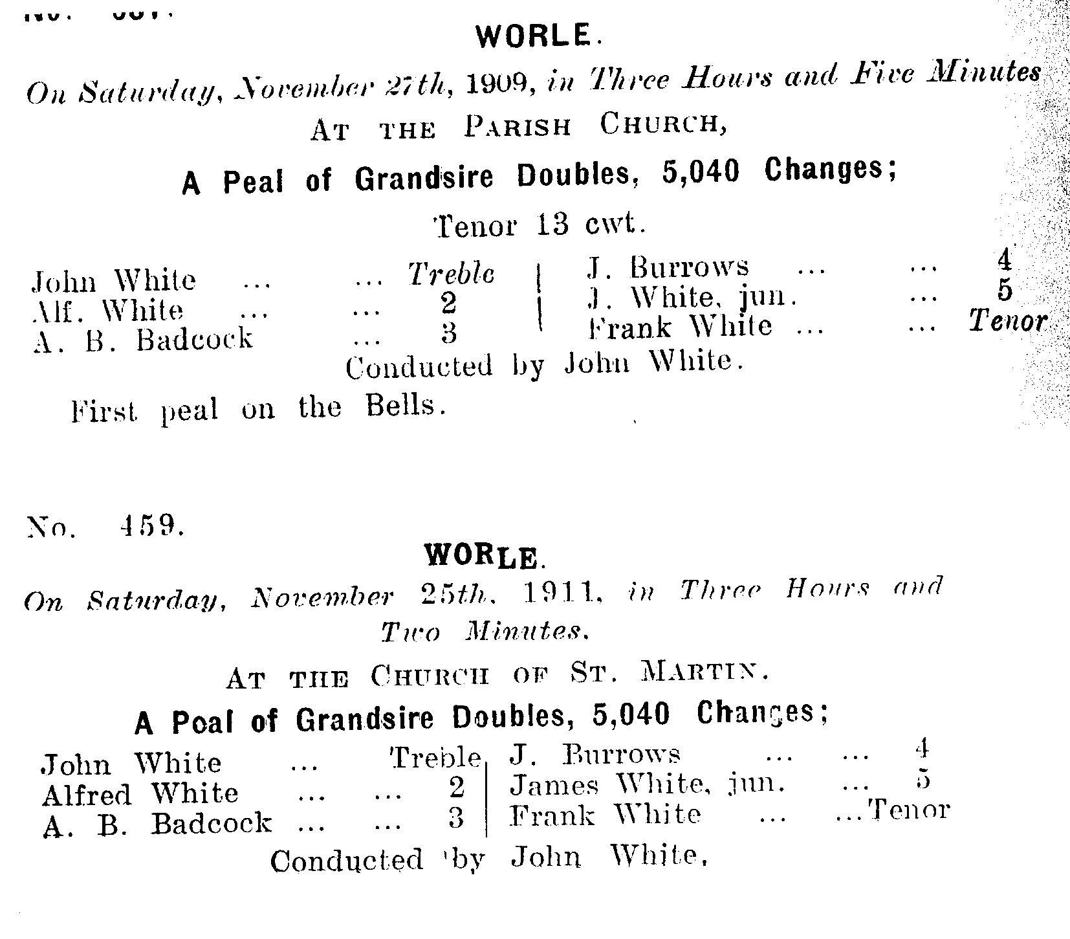
The 4 White boys were brothers:

John White lived at Glendale, Ebdon Road in 1911 when he was a 31 year old mason. John was married to Clara. Their 7 year marriage had produced John (6) and Ellen Jane (4). Clara was 32 years old in 1911 and, like the wife of every other ringer in the band, she was older than her husband. Clara was born in Wroughton, Wiltshire. All of the ringers were born in Worle.

James White was 27 in 1911 and he worked as a wheelwright in Ebdon Road where he lived with wife Mary (28) who was born in Rothesay, Scotland. This couple had been married 6 years and they had 3 children: Florence (4), Kathleen (3) and George (1). Sadly a further child had died as an infant.

Alf(red) White was just 22 years old in 1911 and he had been married for one year to Henrietta a 26 year old from Devizes in Wiltshire. The couple had no children and lived with Alfred's widowed mother Jane. Jane was working as a poultry dealer, Alfred was a plate layer with The Great Western Railway and Henrietta was an ironer in a laundry. The family lived in Hill Road, Worle. The census reveals that Jane had given birth to 8 children in total during her life and that 6 of them survived to 1911.

Frank White, the eldest of the brothers, was 35 in 1911 and married to Edith (37). The couple had 6 children: Emily (13), Dorothy (11), John (8), William (6), Florence (4), and Beatrice (1). The whole family were born in Worle. Frank worked as a road labourer with the district council whilst Edith was working in a laundry, probably with Alfred's wife Henrietta. Emily, the eldest child at just 13, was already working as a domestic servant.

Arthur Binding Badcock was a 35 year old Prudential Insurance Agent in 1911 when he lived at "Farleigh" Worle with his 37 year old wife Alice and children Annie (9) and Jack (5). Alice and Arthur had been married 13 years in 1911. Arthur may have enjoyed getting out to ring as he also had his 73 year mother-in-law living in the family home, Minerva Payne! Sadly Arthur died just 3 years later at the very early age of 38 in Bridgend, Glamorgan.

